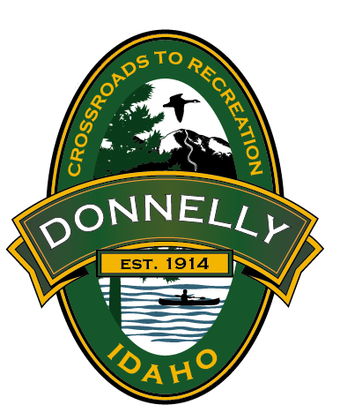
DEVELOPMENT AGREEMENT MODIFICATION APPLICATION
CITY OF DONNELLY
169 Halferty Street
P.O. Box 725
Donnelly, ID 83615
Telephone (208) 325-8859

This application shall be provided with the Master Land Use Application form. In order to avoid handwritten answers this form is provided in word format so the answers to each item can be typed directly hereon. A hard copy of this application shall be provided to the city along with an electronic copy in word format.
File number (To be assigned by city staff):
Previous file number(s) related to the Development Agreement:
What is the justification for the modification(s) to the development agreement:
Along with this application the applicant must provide the following:
- Verification of neighborhood meeting being held prior to submittal of this application.
Note: The verification shall include the time, date, and location of the meeting, a copy of the letter mailed by the applicant, any exhibits presented at the meeting, a copy of the mailing list, and the sign-up sheet from the meeting. Refer to Donnelly City Code Section 18.05.060 for noticing requirements and neighborhood meeting requirements.
- Copy of Deed; and, if the applicant is not the owner, an original notarized statement (affidavit of legal interest) from the owner stating the applicant is authorized to submit this application and that the owner assumes all financial responsibilities for fees if not paid by the applicant).
- Names and addresses of all adjoining property all property owners and purchasers of record owning property located within 300 feet of the exterior boundary of the application property. The addresses shall be submitted to the City on one set of address labels, and a map showing the addresses in relation to the land being considered shall be submitted.
- Legal description, with maps, of the property including meets and bounds to the center line of all adjacent right of ways with appropriate closure to meet the standards of the Valley County Engineer.
- A copy of the existing executed development agreement or approved City Council findings of fact and conclusions of law associated with the most recent development agreement approval.
- Provide a detailed letter of explanation and justification for the modification(s).
- Explain your interest in the original development agreement.
- Date of original approval of the development agreement or conditions of development associated with the approval of the rezone.
- Instrument number and recordation date of the executed development agreement (does not apply if a development agreement associated with the original rezone approval has not been executed).
- Reason for development agreement modification(s), including conditions of development and/or sections to be modified, proposed modifications, and associated exhibits.
- Payment of fees.
- Any additional information to aid in understanding the project.
- One (1) vicinity map (8 ½” x 11”) at 1” = 300’ scale (or similar), labeling the location of the property and adjacent streets.
- A revised concept plan if different than the previously approved plan.
The City does not guarantee acquisition of public services provided by any agency. The developer, property owner and/or applicant of this application does hereby release and indemnify and hold harmless the City of Donnelly from any and all claims, cost, damages, etc., from any individual or organization regarding the acquisition of services which are not affiliated with the City, including but not limited to sanitary sewer service, power, and fire protection.
APPLICANT’S CERTIFICATION:
If the applicant is not the owner, a City of Donnelly Affidavit of Legal Interest shall be provided with any land use applications.
Land use applications are subject to professional review for the purpose of addressing compliance, conformance, situational, and public health, safety and general welfare issues. Professional review may include, but is not limited to, review by engineering, legal, planning, and other qualified professionals. The City of Donnelly reserves the right to contract these services to private firms. The costs of these reviews are passed on to the applicant. These professional fees are separate, and in addition to the City’s application and permit fees.
The Applicant hereby agrees to pay the aforementioned Professional Review Fees and attorney fees, including attorney fees on appeal and expenses incurred on behalf of the City of Donnelly, in the event of a dispute concerning the interpretation or enforcement of the Land Use Application in which the City of Donnelly is the prevailing party and does certify that, to the best of his or her knowledge, all application data and materials provided herewith are true and correct.
I also give permission for City staff to view and enter the subject property in order to fully review this application. I understand that failure to provide complete and accurate information on this application may lead to delay and/or denial of this application.

_____________________________________
Applicant/Representative Printed name

__________________________________________________________
Applicant/Representative Signature Date

